GRAPH NEURAL NETWORK ANALYSIS FOR SCALABLE FAKE PROFILE DETECTION AND BOTNETS
Methodology, Novelty and Key Contributions
Department of Computer Science and Engineering, TKR College of Engineering & Technology
Batch A9 (CSE-A) · Academic year [ACADEMIC YEAR]
Table 1: Project team
S.No. | Student name | Roll number
1 | Bijja Naga Lakshmi | 23K91A0538
2 | Divvela Srivatshav | 23K91A0564
3 | Adumulla Durga | 23K91A0504
4 | Burugula Koushik | 23K91A0550

Project guide: Neelima
Chapter and section numbers quoted in the text (for example Chapter 8 or Section 6.2) refer to the full project report, 17.Final Document. Figures and tables in this document are numbered from 1.

1. METHODOLOGY
This document describes how BotGraph works from end to end and what is new in it. Part 1 gives the pipeline, the data, the algorithms and the reasons they were chosen; Part 2 sets the work against the base paper and separates what is new from what is standard; Part 3 lists the contributions.

1.1 Overall methodology
BotGraph treats fake-account detection as semi-supervised-style node classification on a social graph and botnet discovery as community detection on what the classifier has learned. The work follows seven steps, run in order by the ml package and then served by the API: (1) assemble one graph of 4,533 accounts and 94,456 ties from public data and a seeded generator; (2) build 23 numeric features per account; (3) split the accounts once, stratified by label, into 60 % training, 20 % validation and 20 % test; (4) train a feature-only baseline and three message-passing networks (GCN, GAT, GraphSAGE) on that split with three seeds each; (5) tune the decision threshold on the validation set and report every metric on the untouched test set; (6) keep the architecture with the best validation F1 as the served model, write its fake-probabilities and 64-dimensional embeddings to disk; (7) cluster the suspicious accounts in embedding space with Louvain community detection and describe every cluster.
Two further stages sit outside the offline pipeline. The backend loads the stored scores once, answers every request from memory, and keeps moderator decisions in SQLite. When a moderator asks for it, the pipeline is run again with the logged decisions as extra training labels, and the F1 before and after is recorded.
1. Build the graph (ml/data.py): real topology plus labelled profile rows, posting rows and injected botnets.
2. Engineer features (ml/data.py): profile metadata, posting behaviour, temporal pattern and interaction frequency.
3. Split once (ml/data.py): stratified 60/20/20, identical for every model.
4. Train and compare (ml/gnn.py, ml/train.py): four models, three seeds, class-weighted loss, early stopping on validation F1.
5. Evaluate (ml/train.py, ml/eval.py): accuracy, precision, recall, F1, ROC-AUC, PR-AUC, confusion matrix, and a scalability sweep.
6. Cluster (ml/clustering.py): Louvain over the embeddings of suspicious accounts, scored against the injected botnets.
7. Serve and learn (backend/app): scores, explanations and clusters through the API; moderator decisions feed the next training run.
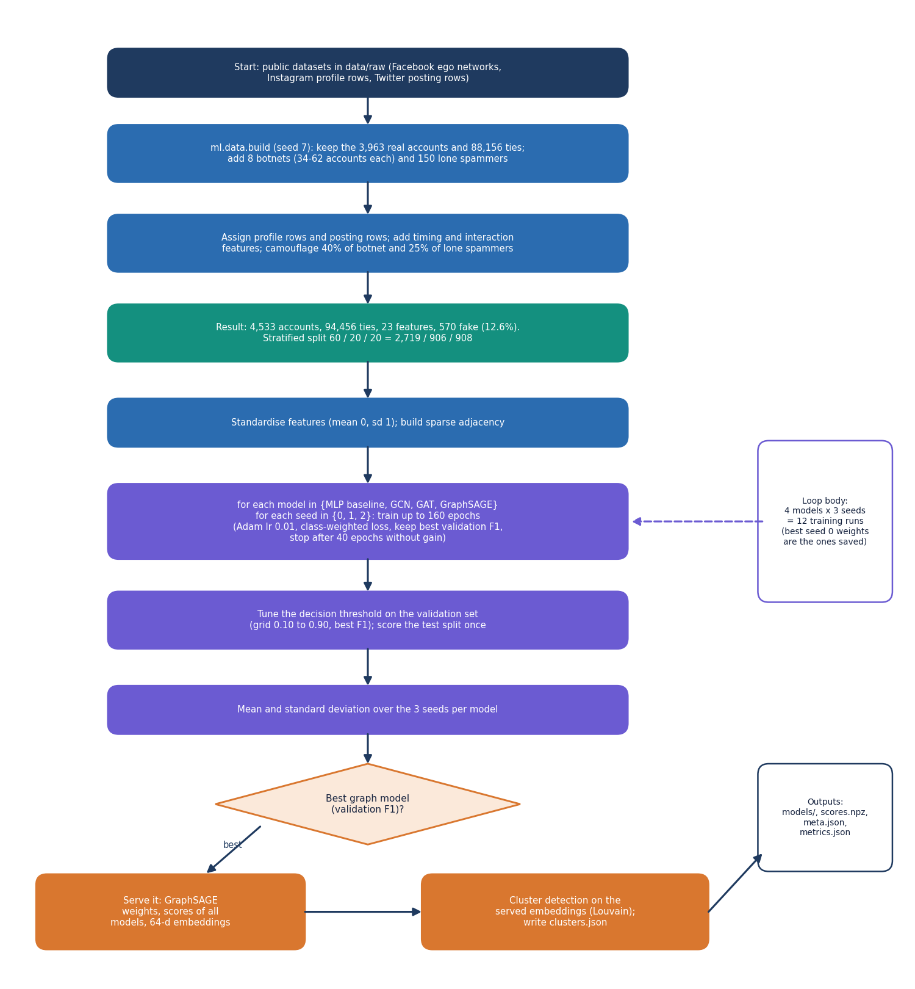
Figure 1: Flow of the offline pipeline from raw data to served artefacts.

1.2 Dataset
No platform data can be scraped or shared, so the graph is assembled from three public datasets and a documented generator. The split between real and synthetic parts is kept visible in the app, in the schema and in every table below.
Table 2: Data sources and what each contributes
Source | Licence | Size used | Used for
SNAP Facebook social circles [12] (ten ego networks, Kaggle mirror) | Public research data | 3,963 accounts, 88,156 ties | All real nodes and ties
Instagram fake, spammer and genuine accounts | CC BY 3.0 | 696 labelled rows | Profile attributes (resampled and jittered)
Twitter Bot Detection Dataset | CC0 | 50,000 rows | Retweets, mentions, post length, hashtags, account age
Injected botnets (ml/data.py, seed 7) | Generated | 570 accounts, 6,300 ties | Known-answer clusters, timing and interaction features, handles

1.2.1 How the graph is assembled
The ten Facebook ego networks are merged into one undirected graph of 3,963 accounts and 88,156 ties. Every real account receives a profile row and a posting row by resampling the labelled datasets. Accounts that will stay genuine draw a genuine profile; accounts that are bots draw a fake profile, except for the camouflaged ones described below.
Eight botnets of 34 to 62 accounts (420 accounts in all; sizes 62, 50, 52, 60, 48, 56, 58, 34) and 150 lone spammers are added. The botnet recipe is:
• every pair of accounts inside a botnet is tied with probability 0.28, plus a ring through all members so the botnet is connected (coordinated mutual follows and likes);
• every bot also follows 2 to 7 real accounts, chosen in proportion to the square root of their degree (follow-spam);
• each pair of botnets has a 0.35 chance of one tie between them;
• each lone spammer follows 3 to 10 real accounts and no other bot;
• members of one botnet share a creation window (about 6 days of spread) and a peak posting hour (within one hour of the botnet's hour).
This adds 6,300 injected ties to the 88,156 real ones, giving 94,456 in total. Fake accounts number 570 (12.6% of 4,533); genuine accounts are the other 3,963.

1.2.2 Camouflage
If every bot carried an obviously fake profile, the profile alone would solve the task and the graph would add nothing. Two rules prevent that. 198 bots (40 % of botnet members and 25 % of lone spammers) are given a genuine-looking profile, and 231 genuine accounts (6 % of real accounts) are given a fake-looking one. A model that reads only the profile therefore cannot be perfect; the neighbourhood has to help. This design choice is deliberate and is also a limitation: the difficulty of the benchmark was set by the authors, not observed on a platform.

1.2.3 Split
Accounts are split once, stratified by label, with a fixed seed: 2,719 for training, 906 for validation and 908 for testing (114 fake accounts in the test split). Because message passing needs the whole graph, all four models see every account's features and ties at training time (transductive setting); only the labels of the training accounts enter the loss. Validation labels select the threshold and the early-stopping epoch; test labels are used for reporting only.
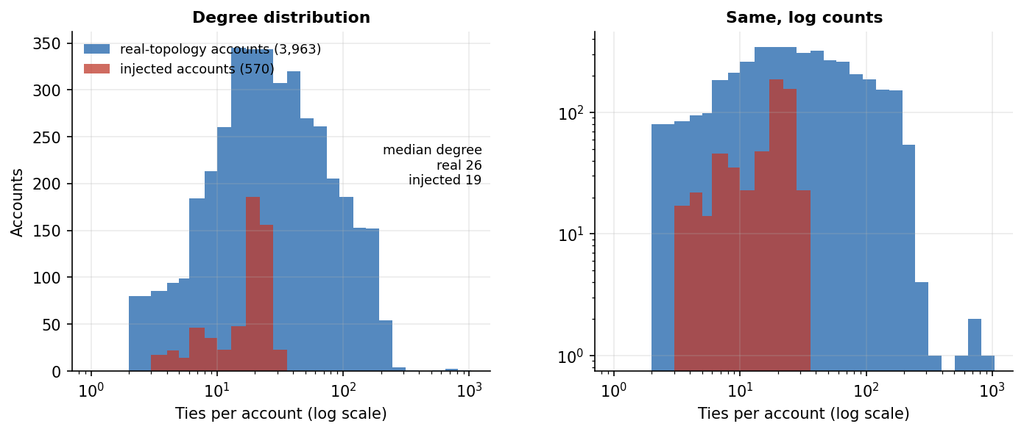
Figure 2: Degree distribution of genuine and fake accounts in the assembled graph.

1.3 Data preparation and node features
Each account is described by 23 numeric features in four groups. Heavy-tailed counts (posts, followers, following, retweets, account age, posting rate, interactions) are log-transformed, the peak posting hour is encoded as a sine and a cosine so that 23:00 and 01:00 are close, and every column is standardised to zero mean and unit variance with the training mean and standard deviation before it reaches a model (the same statistics are stored in scores.npz so the explanation code can reverse them).
Table 3: The 23 node features with the mean value for genuine and fake accounts (stored scale, before standardisation)
Group | Feature | Genuine mean | Fake mean
Profile metadata | Has profile picture | 0.94 | 0.62
Profile metadata | Digits in username | 0.06 | 0.21
Profile metadata | Words in display name | 1.77 | 1.43
Profile metadata | Digits in display name | 0.02 | 0.07
Profile metadata | Name equals username | 0.03 | 0.08
Profile metadata | Bio length | 40.02 | 20.79
Profile metadata | Has external link | 0.24 | 0.10
Profile metadata | Private account | 0.43 | 0.35
Profile metadata | Posts (log) | 3.88 | 2.15
Profile metadata | Followers (log) | 6.65 | 4.83
Profile metadata | Following (log) | 5.84 | 5.01
Profile metadata | Follower / following ratio (log1p) | 1.50 | 0.95
Posting behaviour | Average retweets (log) | 3.62 | 3.61
Posting behaviour | Average mentions per post | 2.50 | 2.52
Posting behaviour | Average post length | 62.57 | 63.88
Posting behaviour | Hashtags per post | 2.51 | 2.54
Temporal pattern | Account age (log days) | 6.62 | 5.51
Temporal pattern | Posts per day (log) | -0.23 | 0.48
Temporal pattern | Posting burstiness | 0.28 | 0.46
Temporal pattern | Share of activity in peak hour | 0.13 | 0.26
Temporal pattern | Peak hour (sine) | -0.52 | -0.53
Temporal pattern | Peak hour (cosine) | 0.40 | 0.05
Interaction frequency | Interactions per week (log) | 3.26 | 3.92

Two things stand out in the table. The profile features separate the classes well on average (profile pictures 0.94 against 0.62, bio length 40 against 21 characters, posts and followers lower for fake accounts), and the timing features separate them even more (burstiness 0.28 against 0.46, share of activity in the peak hour 0.13 against 0.26). The four posting-behaviour features, in contrast, are practically identical for the two classes: the Twitter dataset's bot label carries almost no signal, so these columns behave as realistic noise and are not evidence. The temporal and interaction features are generated by the seeded script, with a bot-leaning and a human-leaning distribution; this matters for how the results are read (Section 6.4 and Chapter 8).
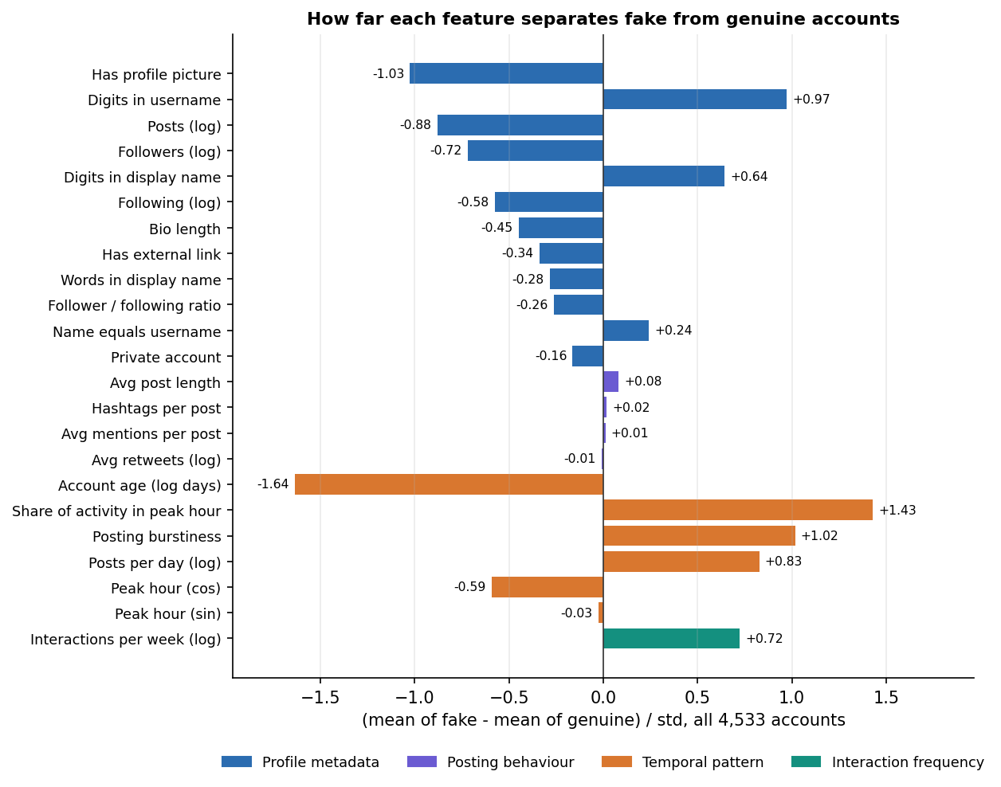
Figure 3: Standardised difference between fake and genuine accounts for each feature group.

1.4 Algorithm choice and justification

1.4.1 Why a graph neural network
A per-account classifier sees only the account's own columns. A bot that copies a genuine profile and posts at human-like rates gives such a classifier nothing to work with, yet its ties are unusual: it follows and is followed by other accounts of the same operation. A graph neural network lets each account's representation depend on its neighbours' features, so the evidence from a camouflaged account's neighbourhood reaches the account itself. The base paper uses the same idea for a different goal, classifying nodes of the Facebook graph by structural role with GraphSAGE [1], [10], and the project brief asks for the three standard architectures to be compared.

1.4.2 Why these three architectures
Table 4: The three message-passing layers compared
Model | How a node combines its neighbourhood | Why it is in the study
GCN [8] | Symmetrically normalised sum over neighbours and self; one weight matrix for both | The standard baseline for graph learning; smoothing is strong, so it tests whether plain smoothing helps
GAT [9] | Attention-weighted sum over neighbours; four heads in the first layer | Lets the model weigh suspicious neighbours more than ordinary ones
GraphSAGE [10] | Separate weights for the node itself and the mean of its neighbours | Keeps the account's own evidence apart from the neighbourhood; the base paper's backbone

1.4.3 Why a feature-only baseline
A graph model that beats nothing proves nothing. The baseline is a two-layer dense network with the same width, dropout, optimiser, loss, split, seeds and early stopping as the graph models, fed the same 23 features, with the graph removed. Its F1 of 0.827 is the number every graph model has to beat. The difference between a graph model and the baseline is the measured contribution of the ties.

1.4.4 Why class weights and a tuned threshold
Only 12.6% of accounts are fake, so plain cross-entropy would reward saying 'genuine' for everything (a classifier that does so scores 87.4% accuracy on the test split). The loss therefore weights the fake class by the square root of the class ratio, which is a milder correction than full inverse-frequency weighting and avoids flooding the queue with false alarms. The decision threshold is then chosen on the validation set from a grid of 33 values between 0.1 and 0.9 to maximise F1, instead of being fixed at 0.5. The headline metric is F1 with precision and recall alongside; accuracy is reported but not used to rank models.

1.4.5 Why Louvain over the embeddings
A botnet is a group of accounts that look alike to the model and are tied to each other. The second hidden layer of the served network gives each account a 64-dimensional embedding in which such accounts are close. Louvain [11] finds densely connected groups by maximising modularity, needs no preset number of clusters and runs in seconds on a few hundred nodes. Combining embedding similarity with real ties lets a group form either because its members behave alike or because they follow each other, and rejects accounts that only happen to share one of the two.

1.5 Mathematical formulation
Let the graph have n accounts, adjacency matrix A (symmetric, no self-loops), feature matrix X ∈ R^(n×23) after standardisation, and labels y_i ∈ {0, 1} (1 = fake). Every model has two hidden layers of width 64, an ELU activation and a linear head with two outputs. H⁽⁰⁾ = X, and for layer l = 1, 2:

1.5.1 Message-passing layers
GCN. With self-loops added, Ã = A + I and D̃ the diagonal degree matrix of Ã:
H⁽ˡ⁾ = ELU( D̃^(-1/2) Ã D̃^(-1/2) H⁽ˡ⁻¹⁾ W⁽ˡ⁾ + b⁽ˡ⁾ ) (1)
In ml/gnn.py the normalised matrix is built once as a sparse tensor and applied with a sparse matrix product.
GraphSAGE (mean aggregator). With N(i) the neighbours of account i:
h_i⁽ˡ⁾ = ELU( W_self⁽ˡ⁾ h_i⁽ˡ⁻¹⁾ + b⁽ˡ⁾ + W_neigh⁽ˡ⁾ · mean_{j ∈ N(i)} h_j⁽ˡ⁻¹⁾ ) (2)
The self term and the neighbour term have separate weight matrices; this is the only one of the three layers that treats 'me' and 'my neighbours' differently.
GAT. Attention coefficients are computed per head k over the neighbours of i and over i itself:
e_ij = LeakyReLU₀.₂( a_srcᵀ W h_j + a_dstᵀ W h_i ), α_ij = exp(e_ij) / Σ_{m ∈ N(i) ∪ {i}} exp(e_im), h_i' = ELU( ‖_k Σ_j α_ij^k W^k h_j ) (3)
The first layer uses four heads of 16 units whose outputs are concatenated into 64 units; the second layer uses one head of 64 units. The softmax over each node's incoming edges is implemented with scatter_reduce (maximum) and index_add_ (sum), which is why GAT results can move by about 0.01 F1 between runs: the summation order is not deterministic.
Baseline. The same two layers with the graph removed: H⁽ˡ⁾ = ELU( H⁽ˡ⁻¹⁾ W⁽ˡ⁾ + b⁽ˡ⁾ ).

1.5.2 Classifier and loss
The head maps the second embedding z_i = H⁽²⁾_i to two logits, and the fake-probability is the softmax of the second component:
p_i = softmax( W_o z_i + b_o )₁ (4)
Training minimises class-weighted cross-entropy over the training accounts T, with weight 1 on the genuine class and w₁ = √(n₀ / n₁) on the fake class, where n₀ and n₁ are the class counts in T:
L = − Σ_{i ∈ T} w_{y_i} · log p(y_i | i) / Σ_{i ∈ T} w_{y_i} (5)
(PyTorch normalises the weighted sum by the sum of the weights.) The network is regularised with dropout [23] 0.3 on the input, between layers and before the head, and L2 weight decay 5 × 10⁻⁴ in Adam [13].

1.5.3 Threshold and metrics
τ* = argmax_{τ ∈ {0.10, 0.125, …, 0.90}} F1( y_val , 1[p_val ≥ τ] ) (6)
An account is flagged when p_i ≥ τ*. With TP, FP, FN, TN counted on the test split:
Precision = TP / (TP + FP), Recall = TP / (TP + FN), F1 = 2 · Precision · Recall / (Precision + Recall) (7)
ROC-AUC is the probability that a randomly chosen fake account receives a higher p than a randomly chosen genuine one, and PR-AUC is the area under the precision-recall curve (computed as average precision). Because fake accounts are 12.6 % of the data, PR-AUC is the stricter of the two.

1.5.4 Clustering
Let S = {i : p_i ≥ 0.30} be the candidate accounts. Each candidate is linked to its K = 5 most similar candidates by cosine similarity of embeddings, with edge weight max(cos(z_i, z_j), 0), and every real tie between two candidates adds weight 1.0 to the pair. Louvain maximises the weighted modularity
Q = 1/(2m) · Σ_{ij} [ w_ij − k_i k_j / (2m) ] · δ(c_i, c_j) (8)
where w_ij is the edge weight, k_i the weighted degree, m the total weight and c_i the community of node i. Communities with fewer than 5 accounts are dropped. For each cluster of size s with E internal real ties:
density = E / ( s (s − 1) / 2 ) (9)
A cluster is labelled coordinated when its density is at least 5 % and diffuse otherwise. Recovery of an injected botnet is measured with recall = |botnet ∩ cluster| / |botnet| and precision = |botnet ∩ cluster| / |cluster| for the best-overlapping cluster; a botnet counts as recovered when both are at least 0.8.

1.5.5 Explanation of a score
For an account i, the app reports gradient × input attribution [25] of the fake-versus-genuine margin m_i = logit₁ − logit₀. Writing x for the standardised feature matrix:
contribution(i, f) = x_if · ∂m_i / ∂x_if, own total = Σ_f contribution(i, f), network = Σ_{j ≠ i} Σ_f x_jf · ∂m_i / ∂x_jf (10)
The seven largest own contributions are shown as bars, and the network term reports how much the other accounts' features push the margin through message passing. This is a first-order approximation of feature importance, not a proof of cause, and the app says so on the screen.

1.6 Model architecture and training configuration
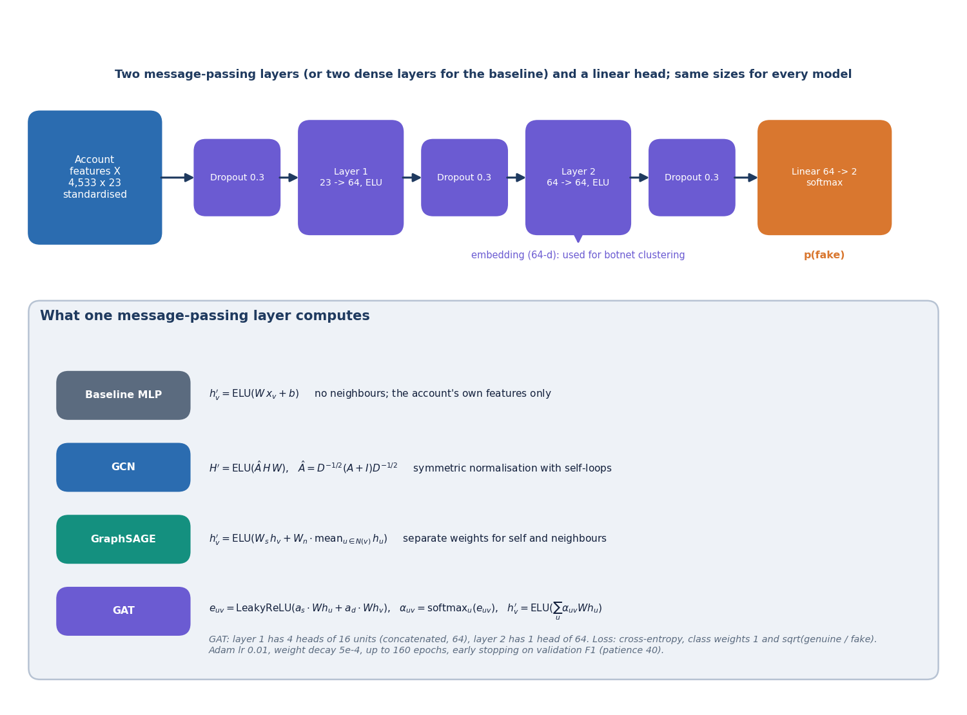
Figure 4: Two-layer message-passing network with a classifier head, and the three layer types that fill the layer slots.
All four models are written in plain PyTorch [14] on sparse tensors; torch-geometric is not used, because its Windows wheels are a frequent build failure and the three layers are short enough to write directly. The models are small enough to train on a laptop CPU in seconds to a minute.
Table 5: Parameter counts and mean training time per model (3 seeds, CPU)
Model | Trainable parameters | Mean training time per run (s) | Uses graph
Feature-only baseline (MLP) | 5,826 | 3.0 | No
GCN | 5,826 | 10.4 | Yes
GAT | 6,082 | 40.6 | Yes
GraphSAGE | 11,394 | 11.7 | Yes

GraphSAGE has about twice the parameters of the other models because each layer holds two weight matrices. The parameter counts were taken from the instantiated models on 23 input features.
Table 6: Training configuration (identical for all models)
Setting | Value
Hidden width | 64
Layers | 2 message-passing (or dense) layers + linear head
Activation | ELU
Dropout | 0.3 (GAT attention dropout 0.2)
Optimiser | Adam, learning rate 0.01, weight decay 5 × 10⁻⁴
Loss | Cross-entropy, fake-class weight √(n_genuine / n_fake)
Epochs | up to 160, early stopping with patience 40 on validation F1 at threshold 0.5
Model selection | best-validation-F1 epoch restored
Seeds | 0, 1, 2 (mean and standard deviation reported)
Threshold | tuned on validation, grid 0.10 to 0.90 in steps of 0.025
Served model | best validation F1 among GCN, GAT, GraphSAGE (GraphSAGE: 0.959)

Training is full-batch: every epoch runs one forward and backward pass over the whole graph. After each epoch the validation F1 is computed at 0.5 and the weights of the best epoch are kept. After training, the probabilities of seed 0 are stored as the served scores, and that run's threshold is the served threshold (0.5 for GraphSAGE).

1.7 Botnet cluster detection
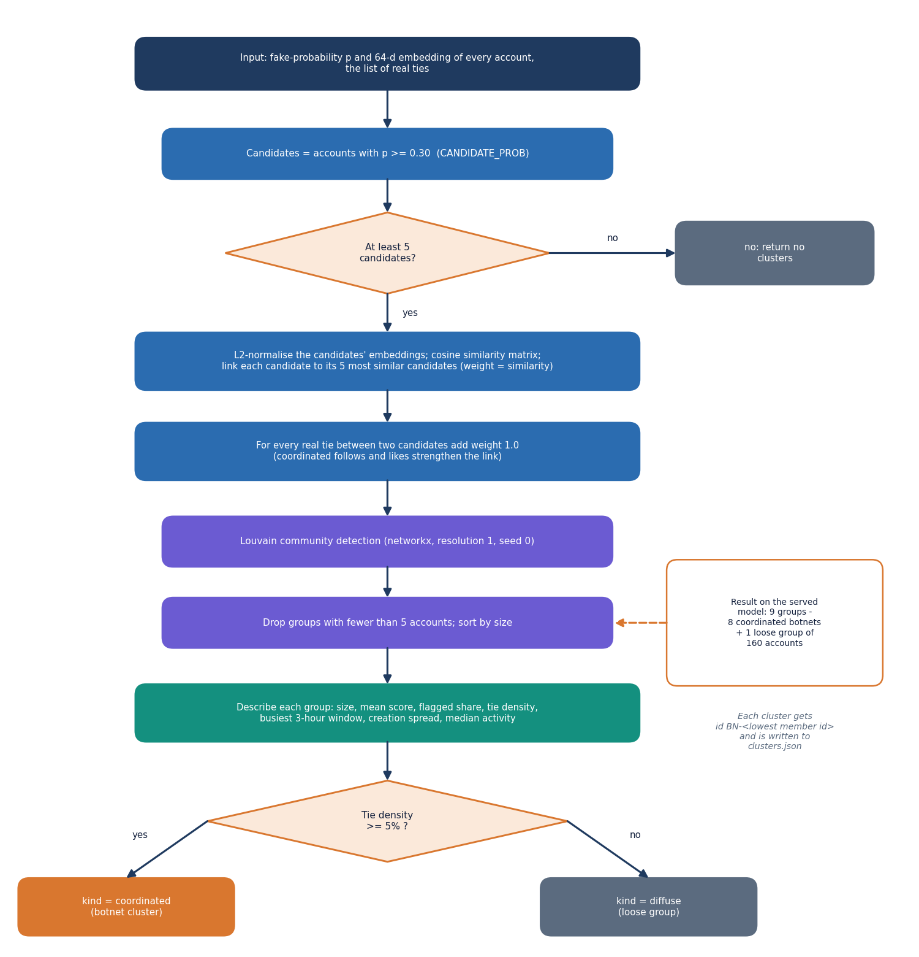
Figure 5: Steps of botnet cluster detection from model scores and embeddings.
Cluster detection runs on the served model's output. Candidates are accounts with p ≥ 0.30, a looser cut than the flagging threshold so that borderline members of a botnet can still be pulled in by their neighbours. Each cluster is described by its size, mean score, share flagged, internal ties and density, the busiest three-hour window and the share of members in it, the spread of creation dates (10th to 90th percentile of account age), and median posting rate, interactions, followers and follower ratio. These descriptions are what the moderator reads in the app before confirming or dismissing a whole cluster.
On the shipped model the procedure finds 9 groups: 8 of 8 injected botnets, each as a single community (mean recall 1.000, mean precision 0.988), plus one loose group of 160 accounts (lone spammers and look-alikes) whose members have almost no ties between them, which the app labels diffuse because its density is 0.0014. Results are discussed in Chapter 8.

1.8 Moderator feedback and retraining
A moderator confirms or dismisses a flagged account, or a whole cluster. Each decision is stored with the moderator, the note, the model's score at that moment and the list of affected accounts. A cluster decision applies to all of its members. When a moderator starts a retraining run, every logged decision becomes a training label (confirm → fake, dismiss → genuine); the latest decision on an account wins.
• Reviewed accounts that lie in the training or validation split join the training set (and leave the validation set); accounts in the test split are never relabelled, so before and after are measured on the same test accounts.
• The run trains all four models with one seed, rewrites the served scores and clusters, and stores the F1 of each model before and after in training_runs.
• The decisions it used are marked with the run number and can no longer be undone.
• Decisions that cannot be used (test-split accounts) are still kept in the log.
The comparison before and after is a single-seed run against the three-seed mean, so small changes in F1 should not be over-read; the purpose of the loop is to show that moderator knowledge can enter the model, not to claim a measured gain from a few demo decisions.

2. NOVELTY AGAINST THE BASE PAPER

2.1 The base paper in brief
The base paper, PruferNET [1], proposes structural features for node classification in social networks. It builds a minimum spanning tree of the SNAP Facebook graph, encodes the tree as a Prüfer sequence [22], derives features from it (label frequency, entropy, unique-label ratio, transition influence, subtree depth) and adds degree, closeness and PageRank centralities and a trust score. A GraphSAGE network (GraphSAGE, 64 hidden units, dropout 0.5, AdamW lr 0.003, 300 epochs) then assigns each node to one of three classes defined by its depth in the tree: Very Shallow, Shallow or Deep. The authors report a test accuracy of 99.63% with the Prüfer features against 96.54% with traditional features on the Facebook graph (4,039 nodes, 88,234 edges, split 60/20/20), and a check on the Email-Eu-core network (986 nodes, 16,064 edges).
The paper is about influence. Its labels are derived from the graph itself, so it contains no fake accounts, no class imbalance, no bots, no coordinated groups, no human review and no measurement of cost as the graph grows. The survey in Chapter 2 identified exactly this gap: the same relational learning has to be applied to fake-profile and botnet detection at platform scale.

2.2 What BotGraph takes from it
• The data family and graph view. The same SNAP Facebook ego networks supply the topology, and accounts and interactions are nodes and edges.
• GraphSAGE as a backbone. It is the best of the three architectures here, as in the base paper's choice of model.
• The evaluation protocol. A 60/20/20 split, a fixed seed for reproducibility, model selection on validation data and one report on the held-out test set.
• The argument that structure adds information a per-node model lacks. The no-graph baseline in BotGraph is the analogue of the paper's traditional-features-only comparison.

2.3 What is different
Table 7: Base paper compared with BotGraph
Aspect | PruferNET (base paper) | BotGraph (this project)
Task | 3-class node classification by MST depth (influence) | Binary fake-account detection plus botnet cluster discovery
Labels | Derived from the graph's own tree depth | Fake / genuine labels from labelled datasets; known botnet membership for scoring clusters
Class balance | Balanced by percentile construction | 12.6 % fake; class-weighted loss and tuned threshold
Models | GraphSAGE only | GCN, GAT, GraphSAGE and a no-graph baseline on one split, three seeds
Features | Prüfer-sequence structure + centralities + trust | 23 attribute features: profile, posting, temporal, interaction
Groups of accounts | Not addressed | Louvain over embeddings; 8 of 8 injected botnets recovered
Human in the loop | None | Moderator queue; decisions become training labels; test split untouched
Scale | Not measured | Training and inference time up to 36,264 accounts and 755,648 ties
Delivery | Method and experiments | Working API, database, web app and a 36-check end-to-end test
Hardware | T4 GPU, 16 GB RAM | CPU only, 16 GB RAM

2.4 What is new and what is standard
None of the three layer types is new: GCN [8], GAT [9] and GraphSAGE [10] are implemented as published, and Louvain [11] is the standard algorithm. The contribution of BotGraph is the combination and its evaluation: a fair comparison of the three architectures with a no-graph control on a graph that has known botnets; clustering driven by what the classifier learned rather than by structure alone; a moderator loop that keeps the test split fixed so that before-and-after F1 is comparable; per-account explanations that separate an account's own traits from what its neighbours add; and a scalability measurement, all inside one usable application. The same imbalance and noise concerns that RABot [2] addresses with learned augmentation and HW-GNN [3] with spectral filtering are handled here more simply, with a class-weighted loss and a validation-tuned threshold, and neither method is reproduced or compared numerically.

2.5 Why the numbers cannot be compared with the base paper
The base paper's 99.63% is accuracy on a three-class depth label whose classes are balanced by construction; BotGraph's headline is F1 on a binary label where a model that says 'genuine' every time already scores 87.4% accuracy. The data differ (the base paper's graph has 4,039 nodes and its labels come from the graph; this graph has 4,533 nodes, part of it generated), the model sizes and optimisers differ, and the base paper's hardware was a T4 GPU. BotGraph's own accuracy on the test split is 0.985 for GraphSAGE, but that figure is shown only to be complete and is not set against the paper's. What can be compared is the direction of the finding: in both studies, adding structural information to a GraphSAGE model helps.

3. KEY CONTRIBUTIONS
The work makes the following contributions.
1. An assembled benchmark graph with a documented schema. Real Facebook ego-network topology, real labelled profile and posting rows and seeded injected botnets are combined into one graph of 4,533 accounts and 94,456 ties, with every real and synthetic part labelled, a 23-feature node schema in four groups and a fixed stratified split.
2. A controlled comparison of GCN, GAT and GraphSAGE. The three architectures and a no-graph baseline share features, split, optimiser, loss and seeds. GraphSAGE reaches F1 0.939 ± 0.006 against 0.827 ± 0.010 for the baseline (+11.2 points), GAT 0.900 ± 0.018 (+7.3) and GCN 0.837 ± 0.009 (+1.0); GCN's recall is below the baseline's.
3. Botnet detection from learned embeddings. Louvain over embedding similarity and real ties recovers 8 of 8 injected botnets as single communities (mean recall 1.000, mean precision 0.988), and each cluster is described by size, density, shared peak hour and creation spread so that a moderator can judge it.
4. A moderator loop that keeps evaluation honest. Confirm and dismiss decisions on accounts and whole clusters become training labels at the next run; reviewed accounts move into training, the test split is never relabelled, and F1 before and after is stored with the run.
5. Explainable scores. Every account shows its probability, the seven own traits that moved the score most (gradient × input) and a separate figure for what the neighbourhood contributes.
6. A scalability measurement. Training and inference time were measured from 4,533 accounts and 94,456 ties to 36,264 accounts and 755,648 ties.
7. A diagnosis of the benchmark itself. The ablation shows that GraphSAGE on node degree alone reaches F1 0.965, so the injected structure is easy and the headline score must not be read as real-platform accuracy.
8. A working application. FastAPI with JWT roles and SQLite, a React moderator interface, one-click setup, and a smoke test of 36 checks that all pass.

